C.S.1428.751 Program Assignment #4
Due: Friday, July 28, 2017

Develop an algorithm using top-down design and step-wise refinement to solve the problem listed below. Then implement your algorithm in C++.

For this assignment you must work with one other student in your section to write a program to satisfy the following specifications (no more than two in a group unless approved by your instructor). Names of both members of your group should be listed in the documentation at the top of the program as well as in the personal information section written as output. Turn in one paper copy per group on the due date. Both members of your group must individually submit an electronic copy of the final project. Be sure both group members submit the same program, or no credit will be given.

Write a complete C++ program that reads the sides of a triangle in inches (real) from an input file, calculates the perimeter and area of the triangle and prints the input values plus the calculated values to an output file. Indicate when the triangle is an equilateral triangle. Inform the user of the filename to which the output has been written.

Input:
The first line on the input file will contain one integer value indicating the number of records (triangles) to process. Each subsequent line (record) will contain three real values separated by spaces (the sides of a triangle). (This suggests the use of a count (for) loop, since the program will ‘know’ in advance how many records to process.)

For full credit, you must process as follows. (See output sample for spacing/alignment, etc.)
(Do not rearrange order of the operands in the formulas provided, or points will be deducted.
Do not use functions other than main, arrays, structures, classes or character ‘strings’ to solve this problem. Assume intelligent, non-vindictive users.)

(You must process using a count loop to receive any credit for this program.)

- Write your personal identifying information to the output file.
- Read the number of records (triangles) to be processed from the input file.
- As long as there are more records to process:
    - Read the sides of a triangle from the input file using only one read statement to read in the values for each record (triangle).
    - Calculate the perimeter of the triangle.
    - If the sides of the triangle are equal,
      - Calculate the area of the equilateral triangle.
      - Write an appropriate message to the output file indicating that the triangle being processed is an equilateral triangle;
    - Otherwise,
      - Use Heron’s formula to calculate the area of the triangle.
    - Write the input values plus the calculated values to the output file as shown in the sample output below. (Format the numeric data to one decimal place.)
- Write your personal identifying information to the screen.
- Write an appropriate message to the screen indicating to the user the name of the output file to which the results have been written.

Be prepared to run your program on any given data. The input will be available on the assignments page no later than Wednesday, July 26. You should test your program for each possible scenario before the release of the actual input values, since your program will be thoroughly tested by the grader.

Area of an equilateral triangle:
area = (s² * sqrt(3)) / 4 , here s represents the length of one side

Heron’s formula to calculate the area of a triangle, given the three sides:
s = perimeter / 2;
area = sqrt(s * (s - side1) * (s - side2) * (s - side3));

(Include the math library to make use of the sqrt function, if necessary.)

Heron's formula as given above is numerically unstable for triangles with a very small angle. An alternative that is considered stable involves arranging the lengths of the sides so that: a ≥ b ≥ c and computing
Note: The parentheses in the above formula are required in order to prevent numerical instability in the evaluation.
We do not yet have enough ‘tools’ in our bag of ‘tricks’; therefore, for the purpose of this assignment, you should assume that the angles are sufficiently large so that numerical instability is not an issue. In other words, do not manually reorder the sides of the triangle as listed in the input file. Use the version of Heron’s formula given in red above adjusted, of course, to the ‘needs’ of C++.

Note:
area = 1/2 * base * height works for a right triangle if you know which of the three sides is the base and which of the three sides is the height (which we don't), plus you are not guaranteed input will be a right triangle.

Using Code::Blocks-C++, create source code in a file named prog4_xxxxxx.cpp, replacing xxxxxx with your Texas State NetID, also known as your account number, your username, your UIC, and your user identification code. Your NetID is made up of your initials followed by a series of digits. Make note of the case of the characters in the filename. e.g. I would name my file prog4_br02.cpp, since br02 is my NetID.

When you work with others, the naming scheme must include all accounts. e.g. If Sally Student (ss0000) and I worked together, we would name our file prog4_br02_ss0000.cpp. (If groups fail to include all TxStateNetIDs in the filename and include all names authoring the code in documentation and program output, no credit will be given.)

To receive full credit for this assignment, you must include a complete documentation block. For this assignment, the complete documentation is provided for you. It is located in prog4_xxxxxx.cpp on the assignments page. Copy the content of prog4_xxxxxx.cpp into the file you just created in Code::Blocks.

Pay special attention to this documentation which is much like that found in the example programs located on the assignments page (‘Hello World’ and the ‘Age Calculation’ programs). You will be required to include such documentation in all future programs.

Print the source code from within Code::Blocks-C++ by following the instructions described in the Code::Blocks-C++ Compiler document under the C.S.1428 Support Materials link on your instructor’s web page, or points will be deducted. Print on the equivalent of the CS_Letter laser printer (single-sided, no holes), or points will be deducted. Include line numbers when printing source code, or points will be deducted. (To receive full credit, you must have changed comments to a bold, dark color before printing, or points will be deducted. We can’t grade what we can’t see!) Don’t forget to turn off the spell check feature before printing, or points will be deducted.

Print the console output from within WordPad by following the instructions described in the Code:Blocks Compiler document under the C.S.1428 Support Materials link on your instructor’s web page, or points will be deducted.

Print the file input (prog4_751inp.txt) from within Code::Blocks, or points will be deducted. Do not include line numbers when printing input or output files, or points will be deducted.

Print the file output (prog4_751out.txt) from within Code::Blocks, or points will be deducted. Do not include line numbers when printing input or output files, or points will be deducted.

Turn in the source code, a copy of the input file, a copy of the console output, and a copy of the output file stapled together in the top left corner (in this order) with the source code on top. Legibly print by hand your full name and section number in the top left corner of the source code.

Don't forget to electronically submit your program on TRACS. Submit only prog4_xxxxxx.cpp AND prog4_751inp.txt. The number of submission attempts is limited, so ‘use them wisely’. Just like with baseball, three strikes, and you’re out! In other words, don’t submit to TRACS until you are absolutely certain you plan on making no more revisions.

No credit will be given if an entire project is submitted.

No credit will be given unless:
- the paper copies and the electronic copies are simultaneously available to the grader.
- the paper copies match the electronic copies.
- all files necessary for the grader to run your program are simultaneously available, which, in this case, means prog4_xxxxxx.cpp and prog4_751inp.txt.

Refer to my programming style guide, lecture outlines and your lecture notes for more programming requirements to include.

Example layout for console output should look like the following:

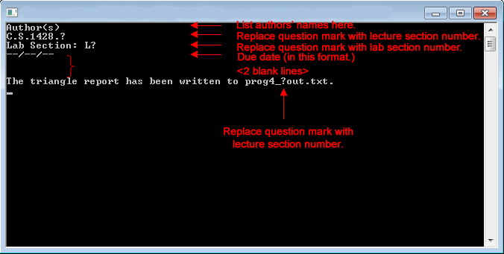

Example layout for file output should look like the following:

